Task 1 Evaluating Model Performance (Jupyter)
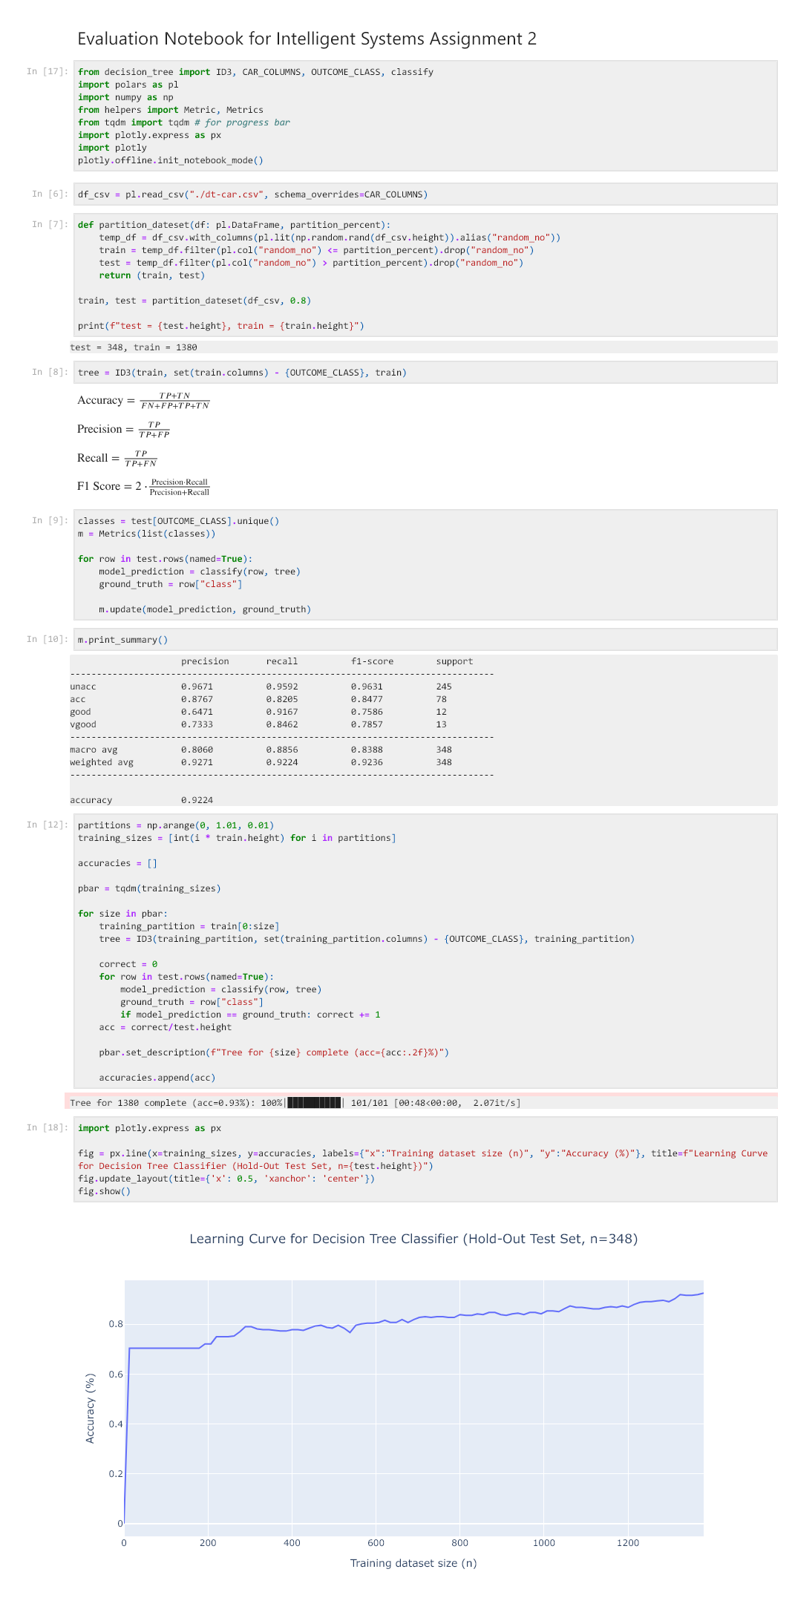

Task 2 Benchmarking NumPy (Jupyter)
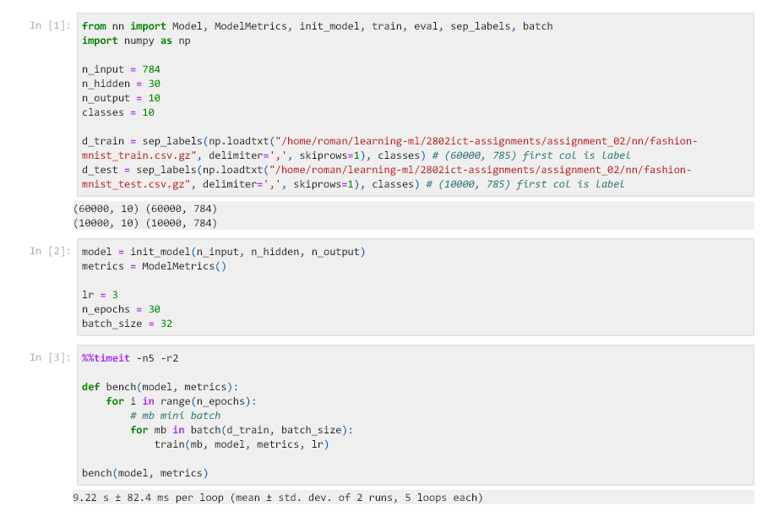

Task 2 Benchmarking GPU Accelerated Variants (Jupyter)
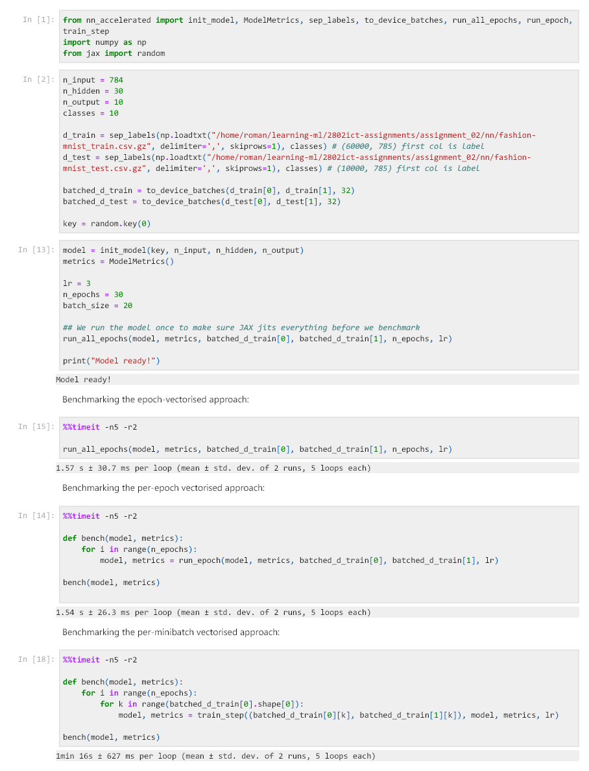

Task 2 Base Case Experiment (Jupyter)
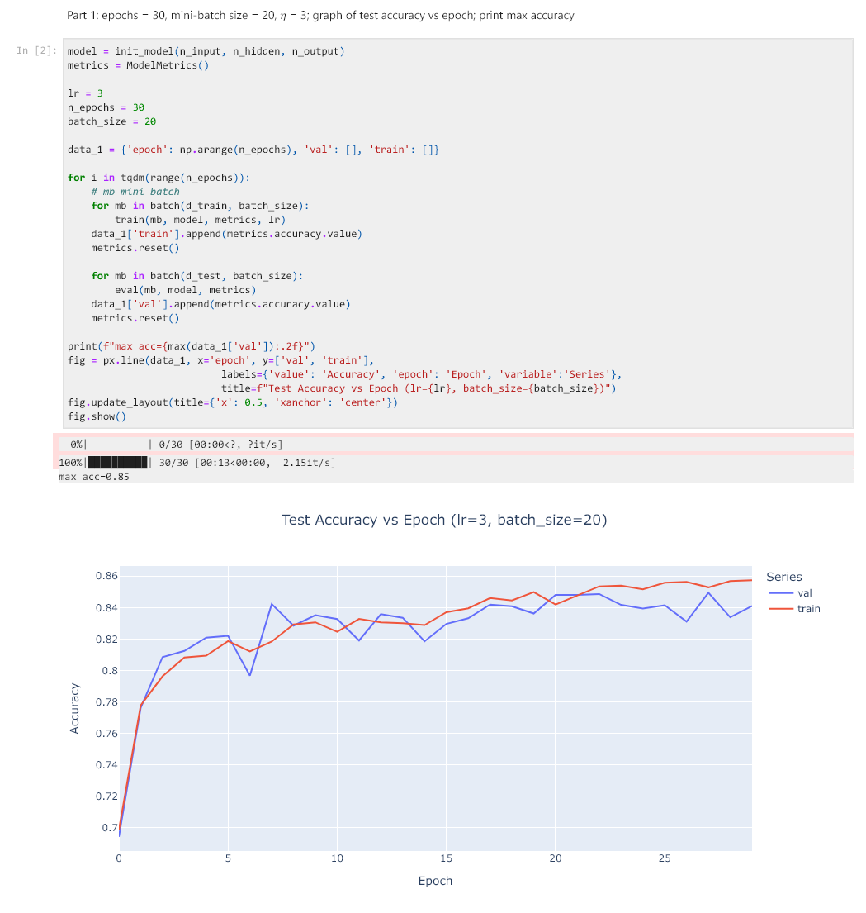

Task 2 Varying Learning Rate Experiment (Jupyter)
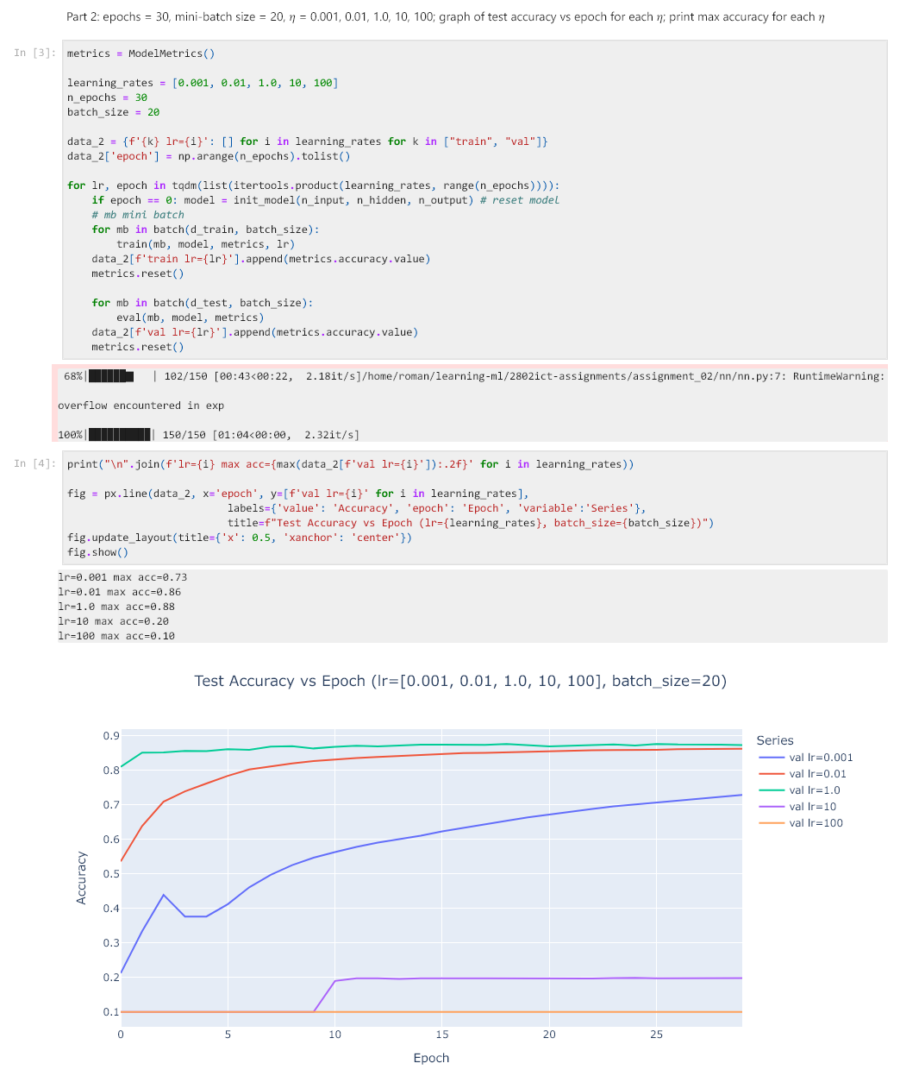

Task 2 Varying Batch Size Experiment (Jupyter)
